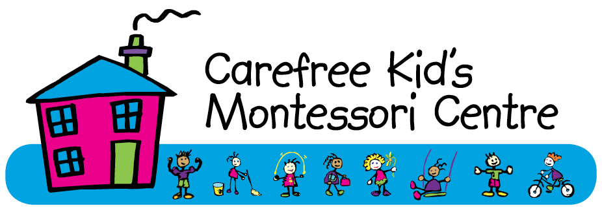
545 Molly Ryde Street
Garsfontein
0081
Cell: 083 632 9175
Tel: 012 348 7099
info@carefreekids.co.za
www.carefreekids.co.za
REGISTRATION FORM
GENERAL INFORMATION
Child’s Information
Surname:
Birth Name:
The name you call your child:
Date of birth:
Gender:
Position in family:
Previous pre-school:
Date of entering Carefree Kid’s:
Home Language:
School Language (Afrikaans / English)
Nationality:
Are you a SA citizen? If not do you have a Residence permit? (Please hand in a certified copy with your application)
How did you hear about Carefree Kid’s?
PLEASE HAND IN CERTIFIED COPIES OF YOUR CHILDS BIRTH CERTIFICATE AND IMMUNIZATION /HEALTH RECORD and a copy of your medical aid card with your entry form.
1st parent / guardian information | 2nd parent / guardian information
Relationship to child: | Relationship to child:
Surname: | Surname:
Name: | Name:
ID Number: | ID Number:
Home Address: | Home Address:
Postal Address: | Postal Address:
Home Telephone: | Home Telephone:
Cell phone: | Cell phone:
Work Telephone: | Work Telephone:
E-mail: | E-mail:
Occupation: | Occupation:
Place of employment: | Place of employment:
Person responsible for paying school and other fees:
Religious affiliation:
Parent’s marital status: Married □ Separated □ Divorced □ Widowed □ Single □ Life partners □

Emergency telephone numbers of friends or relatives:
Name:  Relation:  Contact details: | Name:  Relation:  Contact details:
Indicate on what days your child will attend school:
(4 & 3 days are only available for the 15 months to 3 year environments)

Full day, 5 days/week □ ; Half day, 5 days/week □; Half day, 4 days/week □; Half day 3 days/week □
MEDICAL INFORMATION
Child’s Pediatrician: | Contact Tel:
Family Doctor: | Contact Tel:
Vaccinations: Has your child been inoculated against all child diseases? Please hand in a certified proof with your application.
Allergies:
Please send any necessary medication to school and specify symptoms for e.g. Rash

Food intolerances:

Personal food preferences:

Prior Illnesses:

Chronic Conditions/Medication:

Special precautions and other information:  Undergone surgery? Sustained minor injuries? Received psychiatric care or counseling? | Nature & date:
Medical Aid: | Medical Aid Plan:
Medical Aid Number: | Medical Aid Main Member:
Please attached a copy of your Medical Aid card to your registration form
In case of emergency, which Parent or Guardian should be contacted?
Alternative Contact Person in case of Emergency:
Consent for the school to use another doctor or paramedic in an emergency or to transport your child to the nearest hospital if the need occur? | Signature:
GENERAL
What are his / her interests?
Do you have any concerns about your child who should be brought to our attention?
Anything else you would like to mention about your child or family:
Any activities that your child may not participate in:

I / we herewith declare that the information in this form is correct. I / we have read the terms and conditions and understand and accept them.

I / we understand that the fees are payable monthly or in advance for 12 months of the year. We have to send a proof of payment to info@carefreekids.co.za or 083 632 9175. All school fees are payable before the 3rd of the new month and interest will be charged on late payments. I am required to give one calendar month written notice for my deposit to go towards my last month’s school fees. My deposit will not be paid back into my account. I will be responsible for all outstanding fees in due of notice that my child is leaving the school. I have to give one months written notice for aftercare. I will pay a double monthly payment at the end of November for December and January of the next year.

Signed at PRETORIA on the ____________________ day of _____________________ 20___.

_________________ __________________
SIGNATURE (father/guardian) SIGNATURE (mother/guardian)

____________________

SIGNATURE PRINCIPAL



INDEMNITY FORM

I _____________________________________________________________________________

ID number _____________________________________________________________________

Father/Mother of ________________________________________________________________

Residing at ____________________________________________________________________

_____________________________________________________________________________

_______________________________________________ code _________________

hereby absolve Carefree Kid’s Montessori Centre and its owner and respective employees from any financial, judicial or medical claim resulting from any injury, howsoever caused, sustained by my child or death of my child from any cause, while at school premises or any outing organised by the school during my child’s sojourn there.

Signed at PRETORIA on the ____________________ day of _____________________ 20___.

_________________ __________________

SIGNATURE (father / guardian) SIGNATURE (mother / guardian)

PARENT’S CONSENT FOR THIRD PARTY TO COLLECT THE CHILD

Child’s name: ___________________________________________________________________

I ___________________________ parent of the above-named child give permission for any of the
following persons to collect my child from school:

1. ___________________________________ relationship _______________________________

2. ___________________________________ relationship _______________________________

3. ___________________________________ relationship _______________________________

4. ___________________________________ relationship _______________________________

Parent’s signature: _________________________

Date: ____________________________________

Tel (h):___________________________________ Tel (w) (M): _______________________

Tel (w) (F): ________________________________

Please keep us informed of changes – particularly phone numbers.

CONSENT LETTER MEDIA

Herewith I, ______________________________ ID no. __________________________________,
Parent/guardian of____________________________________________ give
Carefree Kid’s Montessori Centre permission to make use of my child/children’s photos for advertisement purposes. Either displaying it on the website, application, cellphone or use it in a booklet or pamphlet form.
Signed on____________________________________ at __________________________________

____________________________
Signature parent/legal guardian

